Hitchcock Film Analysis

Student Name:
Class:
Date:

Select one Hitchcock film and describe the salient features of Alfred Hitchcock’s distinctive style. Look at setting, costume, lighting, and staging and analyze how all these elements come together to influence the viewer’s perspective on the characters and their situations. As always, choose at least two scenes to use as supporting examples for your argument. Screenshot each of them. Be specific in your analysis, and do not summarize.

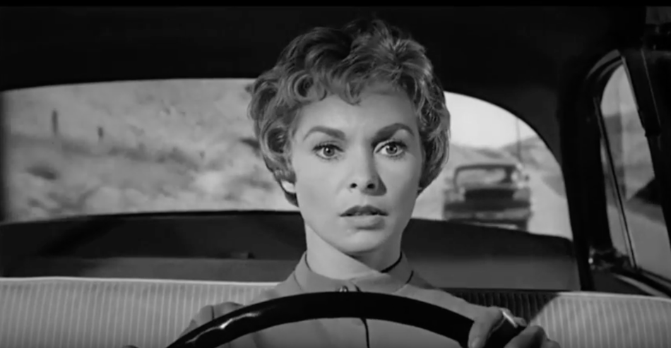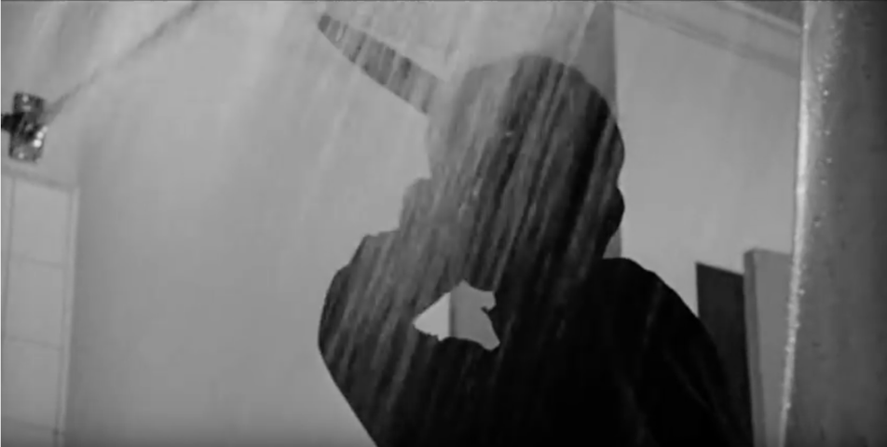

In his films, Alfred Hitchcock blends several separate components to establish his distinctive look. You will witness this style in the film Psycho. What's noticeable in this is the sequence where Marion races away from the police. The environment of the automobile is the first important aspect of this scene. This setting, in particular, allows us to understand the plot. The background arrangement produced by the rear window represents the viewer's attention and highlights the car that follows Marion. The tiny space in the car, for the most part, gives the sense that Marion has little escape. In this season, the costume is also important, as Marion's outfit's put-together and polished appearance contrast with her panic condition. To show that it is mid-day and quick and underline Marion's facial expressions, this scene used bright lighting.
The majority of the acting is included in the staging of this scene. One can see Marion darting between the mirrors with her eyes and spinning the vehicle relatively ridiculously. In the sequence, both of these factors function together to illustrate to the audience why Marion is scared because she is at risk of being caught for stealing the cash. The shower scene is another scene that reveals some of the elements that Hitchcock used to build his look. For the viewer of this film, the mood is truly successful, offering a calm feeling, but it's still a claustrophobic world where everybody expects to be alone. Since Marion is nude, which causes a great sense of insecurity, this scene's costume is significant. The murderer is often dressed as an older boy, generally credited as innocent, which juxtaposes the character's abuse.
In this series, the lighting is important because the suspect was backlit to create a silhouette that offers a sense of mystery over who the murderer is. This scene's staging was carried out quite well. Marion's close-up facial expressions represent true terror and distress, while her frantic body movements create a feeling of panic. In the meantime, the assassins' actions are rather stagnant and calculated, rendering it as though they have no emotions. The components of this scene together give the viewer shock value. They let the viewer perceive Marion as vulnerable even though she does not run or hit out. And it also makes you fear as it is exposed to you that even the most boring activities involving stuff considered innocuous remain dangerous.

